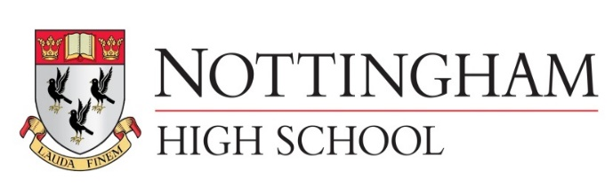
Main meal junior school lunch tariff September 2018

Main Meal £2.40
Main Meal (MD) inc hot or cold pudding or fruit £3.00
Pasta £2.40
Pasta (MD) inc hot or cold pudding or fruit £3.00
Explore bar £1.75
Explore bar (MD) inc hot or cold pudding or fruit £2.40
Jacket potato with 2 items £1.70
Jacket potato (MD) inc hot or cold pudding or fruit £2.40
Vegetables or salad are included
Salad bowl 50p (Separate bowl to any meal)

Hot pudding 75p
Fruit 75p
Fruit jelly (v) 75p
Mousse 75p
Grab N Go Junior school lunch tariff

Sandwich £1.55
Sub roll £1.65
Junior joes £1.95
Fruit 70p
Fruit jelly (v) 70p
Mousse 70p

