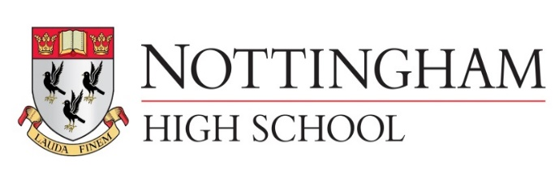
Main meal senior school lunch tariff September 2018
Main Meal £2.90
Main Meal (MD) inc hot or cold pudding or fruit and drink £4.10
Pasta (Variety bar) £2.90
Pasta (Variety bar) (MD) inc hot or cold pudding or fruit £4.10
Explore bar £2.40
Explore bar (MD) inc hot or cold pudding or fruit and drink £3.60
Jacket potato with 2 items £2.40
Jacket potato (MD) inc hot or cold pudding or fruit and drink £3.60
Vegetables or salad are included
Salad bowl 80p (Separate bowl to any meal)
Hot pudding 85p
Fruit 85p
Homemade yoghurt pots, fruit pots all 85p
Homemade flapjack, cakes and cookies all 85p
500ml aqua splash 85p
A selection of fresh juices or milk drinks 80p
Grab N Go senior school lunch tariff
Sandwich £1.55 (meal deal inc Sandwich or sub roll, Drink, cookie fruit or crisps £3.10 3 items)
Sub roll £1.65
Chicken joes £2.80 (meal deal £3.75 inc Drink, cookie fruit or crisps 3 items)
Fruit each portion 40p
Homemade yoghurt pots, fruit pots all £0.85
Homemade flapjack, cakes and cookies all £0.85
500ml aqua splash 85p
A selection of fresh juices or milk drinks 80p

