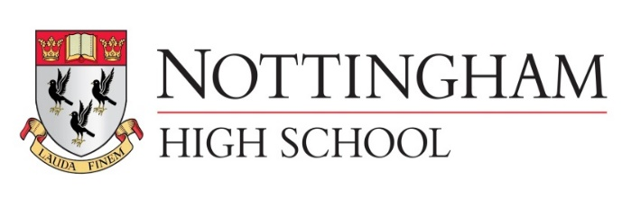
Main meal senior school lunch tariff September 2020
Main Meal £3.00
Main Meal (MD) inc hot or cold pudding or fruit and drink £4.25
Pasta (Variety bar) £3.00
Pasta (Variety bar) (MD) inc hot or cold pudding or fruit £4.25
Explore bar £2.50
Explore bar (MD) inc hot or cold pudding or fruit and drink £3.70
Jacket potato with 2 items £2.50
Jacket potato (MD) inc hot or cold pudding or fruit and drink £3.70
Vegetables or salad are included
Salad bowl £1.00 (Separate bowl to any meal)
Hot pudding 90p
Fruit 90p
Homemade yoghurt pots, fruit pots all 90p
Homemade flapjack, cakes and cookies all 90p
500ml aqua splash 90p
A selection of fresh juices or milk drinks from 85p
Grab N Go senior school lunch tariff
Sandwich £1.60 (meal deal inc Sandwich or sub roll, Drink, cookie fruit or crisps £3.20 3 items)
Sub roll £1.70
Chicken joes £2.90 (meal deal £3.90 inc Drink, cookie fruit or crisps 3 items)
Fruit each portion 50p
Homemade yoghurt pots, fruit pots all £0.90
Homemade flapjack, cakes and cookies all £0.90
500ml aqua splash 90p
A selection of fresh juices or milk drinks from 85p

