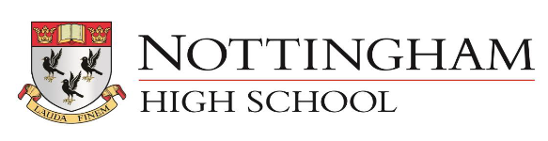

GENDER PAY GAP REPORT – APRIL 2019
1. Mean Hourly Rate Gender Pay Gap 37%
2. Median Hourly Rate Gender Pay Gap 66%
These figures appear to have increased due to a greater increase in part time females, zero hours females and TTO females compared to their male counterparts.
The workforce profile for the 3 years is slightly different due to the timing of some pay claims possibly affected by different Easter breaks and 2019 includes Holiday Club pay claims.
 | 2017 | 2018 | 2019
employees paid in the relevant pay period | 292 | 265 | 277
full time females | 55 | 60 | 57
Full time males | 69 | 67 | 63
part time females | 21 | 23 | 28
part time males | 9 | 6 | 10
TTO females | 62 | 60 | 62
TTO males | 13 | 12 | 11
zero hours females | 22 | 17 | 23
zero hours males | 41 | 20 | 23

3. Gender Quartile Percentages
Upper Quartile
Proportion of Males is 67%
Proportion of Females is 33%
Upper Middle Quartile
Proportion of Males is 30%
Proportion of Females is 70%
Lower Middle Quartile
Proportion of Males is 38%
Proportion of Females is 62%
Lower Quartile
Proportion of Males is 19%
Proportion of Females is 81%
Commentary
We are satisfied that we pay the same rate for the same role, regardless of gender.
The gap seen in the mean and median figures, as well as the Lower Middle and Lower Quartiles can be explained by the fact that the lowest hourly rates tend to go with Domestic and Catering Assistant roles which we run in house.
We have analysed this in more detail and the pay gap reduces to 36%/46% when the highly paid Music teachers are removed and other zero hours hourly paid staff.
The gap for academic staff with the removal of SMT and Music is 12%/10%.
Support staff have a -2% (positive) median for female staff when Catering and Cleaning staff are removed.
4. Bonus Gap
No bonuses were paid in 2019.

