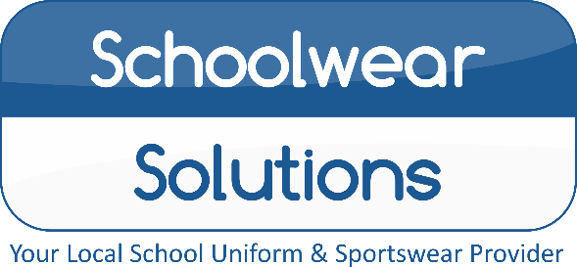
By Morleys
PLEASE
DON’T DELAY
ALL ORDERS MUST BE PLACED
BY 31ST JULY
TO GUARENTEE DELIVERY BEFORE
‘BACK TO SCHOOL’
Royal Logo Sweatshirt Available £8.25
Nottingham High Junior School
Uniform Price List 2021
Uniform items | From
Black Trutex Boys/Girls Blazer with Logo | £30.99
Blazer Badge | £5.25
School Junior House Ties | £6.75
Red Pullover with Logo | £20.99
Red Cardigan with Logo | £22.99
Black Coat with Logo (Optional) | £30.75
Red Legionnaires Cap with Logo | £8.25
Black Ski Hat with Logo | £8.25
White Short Sleeve/Long Sleeve  Shirts and Blouse | Available
Mid Grey Boys Trouser | Available
Mid Grey Boys Short | Available
Mid Grey Girls Skirt | Available
Mid Grey Girls Tenby Pinafore | Available
Mid Grey Girls Kirby Trouser | Available
Red/White Avon Summer Dress | £14.50
Instore Shopping: All COVID-secure measures in place, we hope to change back to “normal” soon…
Online Shopping: Free Click and Collect from store, Home delivery also available…
Appointments Available: Book online, address below.
Summer Opening Hours
Monday - Saturday 9.00am – 5.00pm
Sunday Closed
Winter Opening Hours
Mon – Wed – Fri – Sat 10am – 3pm
Tue – Thu – Sun Closed
PLEASE CHECK OUR WEBSITE FOR UPDATES

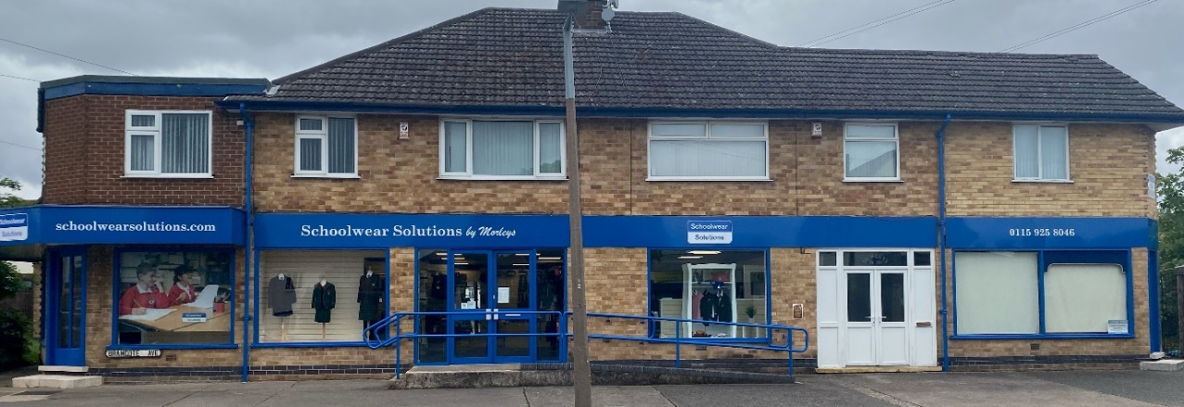
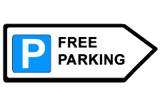
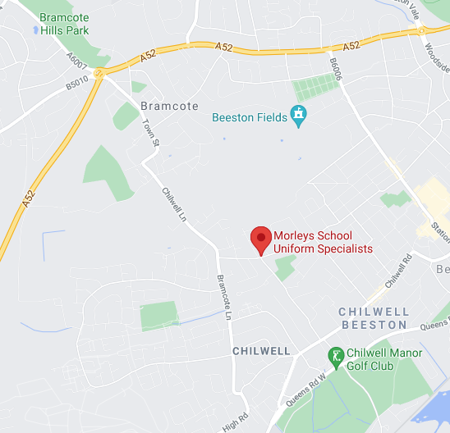
Reserve your
Uniform today!
For a small £5 deposit
116-118 Bramcote Avenue, Chilwell, Notts, NG9 4DR
T: (01159) 258 046 E: chilwellmorleys@gmail.com
www.schoolwearsolutions.com
E&OE Correct at the time of printing

