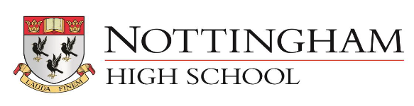

GENDER PAY GAP REPORT – APRIL 2020
1. Mean Hourly Rate Gender Pay Gap 30% down from 37%
2. Median Hourly Rate Gender Pay Gap 54% down from 66%
These figures appear to have decreased slightly.
The workforce profile for the 4 years is slightly different due to the timing of some pay claims possibly affected by different Easter breaks and 2019 includes Holiday Club pay claims but 2020 does not.
 | 2017 | 2018 | 2019 | 2020
employees paid in the relevant pay period | 292 | 265 | 277 | 276
full time females | 55 | 60 | 57 | 62
Full time males | 69 | 67 | 63 | 70
part time females | 21 | 23 | 28 | 29
part time males | 9 | 6 | 10 | 8
TTO females | 62 | 60 | 62 | 64
TTO males | 13 | 12 | 11 | 11
zero hours females | 22 | 17 | 23 | 13
zero hours males | 41 | 20 | 23 | 19

3. Gender Quartile Percentages
Upper Quartile
Proportion of Males is 66%
Proportion of Females is 34%
Upper Middle Quartile
Proportion of Males is 31%
Proportion of Females is 69%
Lower Middle Quartile
Proportion of Males is 41%
Proportion of Females is 59%
Lower Quartile
Proportion of Males is 25%
Proportion of Females is 75%
Commentary
We are satisfied that we pay the same rate for the same role, regardless of gender.
The gap seen in the mean and median figures, as well as the Lower Middle and Lower Quartiles can be explained by the fact that the lowest hourly rates tend to go with Domestic and Catering Assistant roles which we run in house.
We have analysed this in more detail and the pay gap reduces to 27%/43% when the 18 hourly paid Music teachers are removed.
4. Bonus Gap
No bonuses were paid in 2020.

