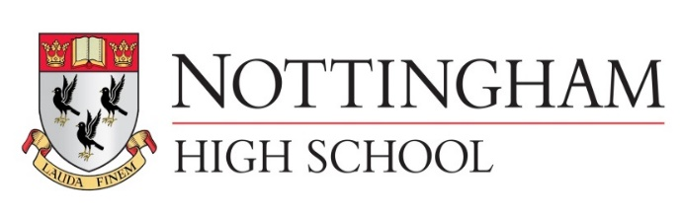
Main meal senior school lunch tariff September 2021
Main Meal £3.18
Main Meal (MD) inc hot or cold pudding or fruit and drink £4.50
Pasta (Variety bar) £3.18
Pasta (Variety bar) (MD) inc hot or cold pudding or fruit £4.50
Explore bar £2.65
Explore bar (MD) inc hot or cold pudding or fruit and drink £3.92
Jacket potato with 2 items £2.65
Jacket potato (MD) inc hot or cold pudding or fruit and drink £3.92
Vegetables or salad are included
Salad bowl £1.06 (Separate bowl to any meal)
Hot pudding 95p
Fruit 95p
Homemade yoghurt pots, fruit pots all 95p
Homemade flapjack, cakes and cookies all 95p
500ml aqua splash 95p
A selection of fresh juices or milk drinks from 85p
Grab N Go senior school lunch tariff
Sandwich £1.70 (meal deal inc Sandwich or sub roll, Drink (95p), cookie (95p) , fruit (95p) or crisps (90p) £3.40 for 3 items)
Sub roll £1.80
Chicken joes £3.07 (meal deal £4.10 - inc Drink, cookie fruit or crisps 3 items)
Fruit each portion 53p
Homemade yoghurt pots, fruit pots all 95p
Homemade flapjack, cakes and cookies all 95p
500ml aqua splash 95p
A selection of fresh juices or milk drinks from 85p

