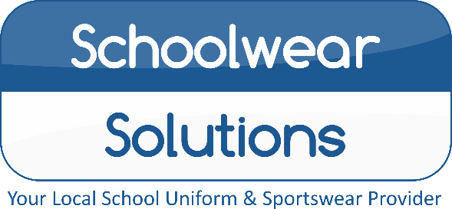
By Morleys
Nottingham High Senior School
Uniform Price List 2021
Uniform items | From
Black Trutex Boys/Girls Blazer with Logo | £30.99
Blazer Badge | £5.25
School Senior House Colour Ties | £11.50
Black Pullover with Logo | £20.95
Black Ski Hat with Logo | £8.25
White Short Sleeve/Long Sleeve  Shirts and Blouse | Available
Black Boys Trousers | Available
Black Twin Pocket Skirt | Available
Black Stitch down Pleat Skirt | Available
Black Girls Slim fit Trouser | Available
Black Girls Greenwich Trouser | Available
Instore Shopping: All COVID-secure measures in place, we hope to change back to “normal” soon…
Online Shopping: Free Click and Collect from store, Home delivery also available…
Appointments Available: Book online, address below.
Summer Opening Hours
Monday - Saturday 9.00am – 5.00pm
Sunday Closed
Winter Opening Hours
Mon – Wed – Fri – Sat 9.30am – 4.30pm
Tue – Thu – Sun Closed
PLEASE CHECK OUR WEBSITE FOR UPDATES

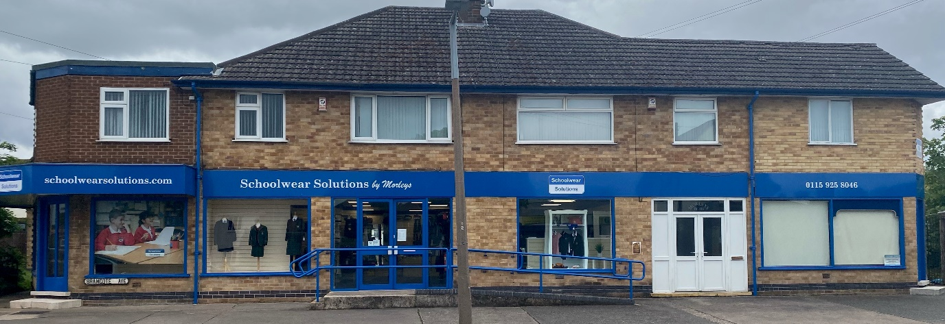
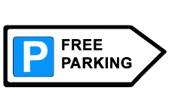
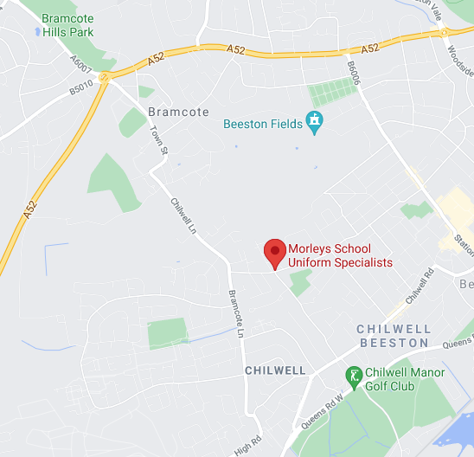
Reserve your
Uniform today!
For a small £5 deposit
116-118 Bramcote Avenue, Chilwell, Notts, NG9 4DR
T: (01159) 258 046 E: chilwellmorleys@gmail.com
www.schoolwearsolutions.com
E&OE Correct at the time of printing

