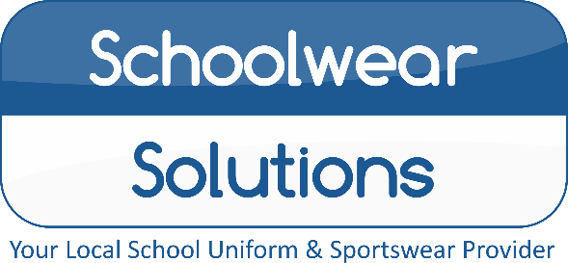
By Morleys
PLEASE
DON’T DELAY
ALL ORDERS MUST BE PLACED
BY 30th JULY
TO GUARENTEE DELIVERY BEFORE
‘BACK TO SCHOOL’
Royal Logo Swe
Nottingham High Junior School
Uniform Price List 2022
Uniform items | From
Black Boys/Girls Blazer with Logo | £32.50
Blazer Badge | £5.99
School Junior House Ties | £6.75
Red Pullover with Logo | £20.99
Red Cardigan with Logo | £23.99
Black Coat with Logo (Optional) | £32.50
Red Legionnaires Cap with Logo | £8.99
Black Ski Hat with Logo | £8.99
White Short Sleeve/Long Sleeve  Shirts and Blouse | Available
Mid Grey Boys Trouser | Available
Mid Grey Boys Short | Available
Mid Grey Girls Skirt | Available
Mid Grey Girls Tenby Pinafore | Available
Mid Grey Girls Kirby Trouser | Available
Red/White Avon Summer Dress | £15.50
Instore Shopping: All COVID-secure measures in place, we hope to change back to “normal” soon…
Online Shopping: Free Click and Collect from store, Home delivery also available…
Appointments Available: Book online, address below.
Summer Opening Hours
Monday - Saturday 9.00am – 5.00pm
Sunday Closed
Winter Opening Hours
Mon – Wed – Fri – Sat 9:30am – 4:30pm
Tue – Thu – Sun Closed
PLEASE CHECK OUR WEBSITE FOR UPDATES

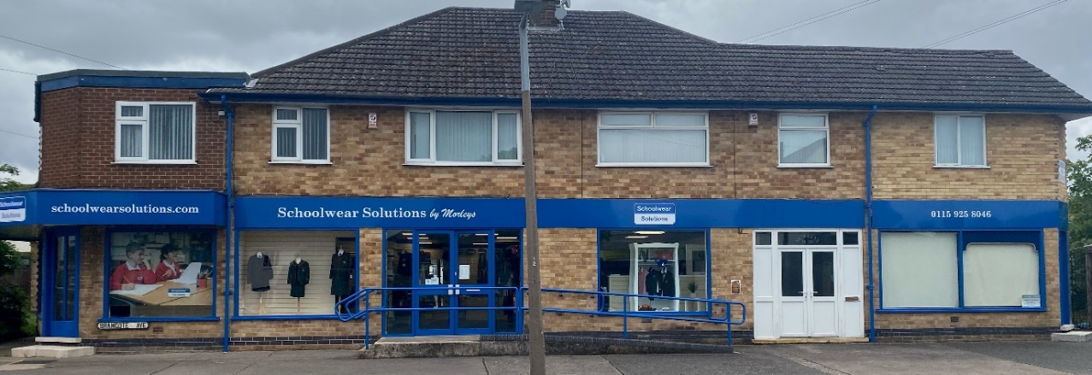
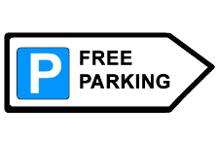
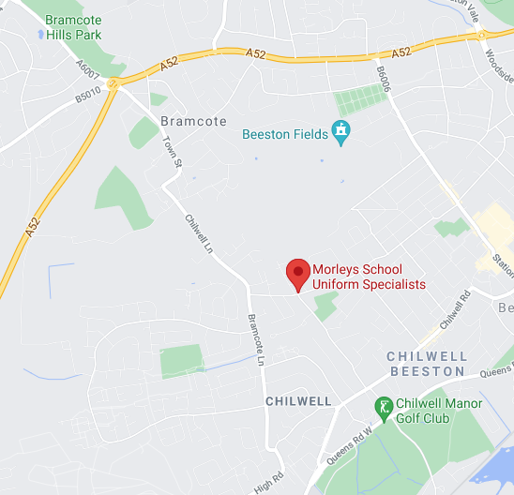
Reserve your
Uniform today!
For a small £5 deposit
116-118 Bramcote Avenue, Chilwell, Notts, NG9 4DR
T: (01159) 258 046 E: chilwellmorleys@gmail.com
www.schoolwearsolutions.com
E&OE Correct at the time of printing

