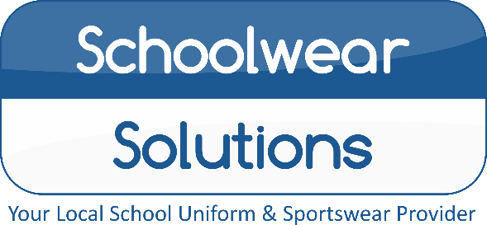
By Morleys
PLEASE
DON’T DELAY
ALL ORDERS MUST BE PLACED
BY 30th JULY
TO GUARENTEE DELIVERY BEFORE
‘BACK TO SCHOOL’
Royal Logo Sweat
Nottingham High Senior School
Uniform Price List 2022
Uniform items | From
Black Trutex Boys/Girls Blazer with Logo | £32.50
Blazer Badge | £5.99
School Senior House Ties | £11.50
Black Pullover with Logo | £21.99
Black Ski Hat with Logo | £8.99
White Short Sleeve/Long Sleeve  Shirts and Blouse | Available
Black Boys Trousers | Available
Black Twin Pocket Skirt | Available
Black Stitch down Pleat Skirt | Available
Black Girls Slim fit Trouser | Available
Black Girls Greenwich Trouser | Available
Black Vortex Plain Coat (Optional) | Available
Instore Shopping: All COVID-secure measures in place, we hope to change back to “normal” soon…
Online Shopping: Free Click and Collect from store, Home delivery also available…
Appointments Available: Book online, address below.
Summer Opening Hours
Monday - Saturday 9.00am – 5.00pm
Sunday Closed
Winter Opening Hours
Mon – Wed – Fri – Sat 9:30am – 4:30pm
Tue – Thu – Sun Closed
PLEASE CHECK OUR WEBSITE FOR UPDATES

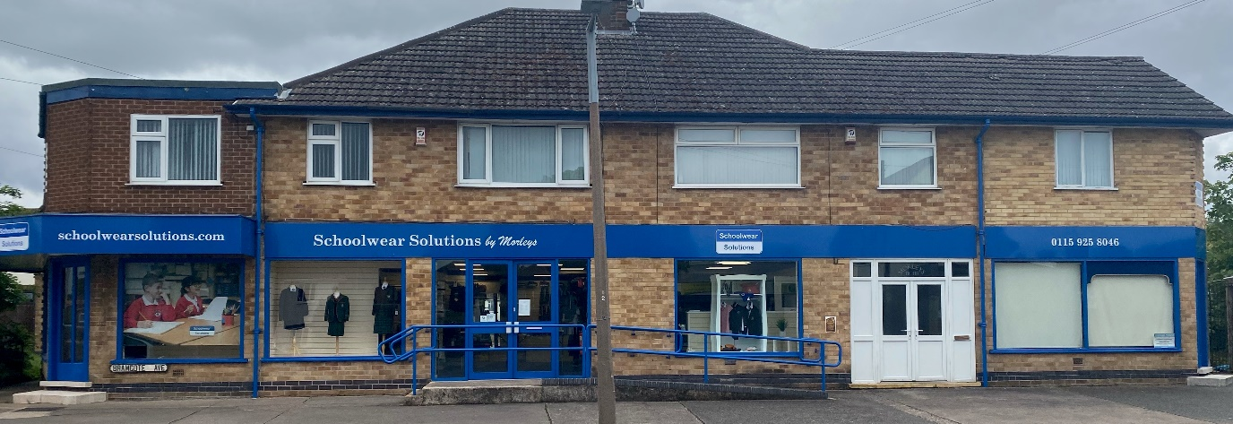
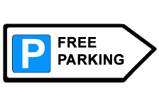
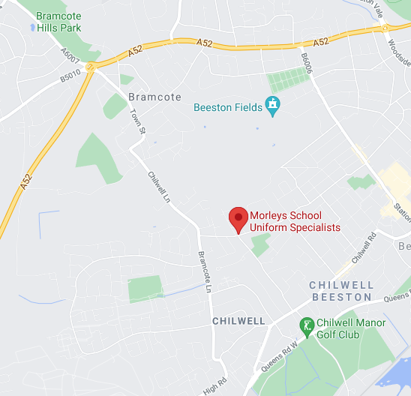
Reserve your
Uniform today!
For a small £5 deposit
116-118 Bramcote Avenue, Chilwell, Notts, NG9 4DR
T: (01159) 258 046 E: chilwellmorleys@gmail.com
www.schoolwearsolutions.com
E&OE Correct at the time of printing

