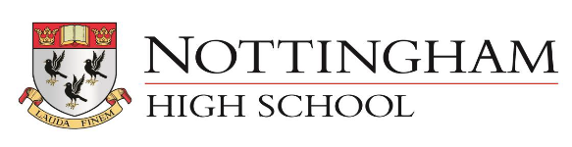

GENDER PAY GAP REPORT – APRIL 2022
1. Mean Hourly Rate Gender Pay Gap 24% down from 28%
2. Median Hourly Rate Gender Pay Gap 31% down from 37%
These figures decreased again slightly.
The workforce profile for the 5 years is slightly different due to the timing of some pay claims possibly affected by different Easter breaks Holiday Club pay claims.
 | 2018 | 2019 | 2020 | 2021 | 2022
employees paid in the relevant pay period | 265 | 277 | 276 | 268 | 284
full time females | 60 | 57 | 62 | 58 | 70
Full time males | 67 | 63 | 70 | 66 | 69
part time females | 23 | 28 | 29 | 29 | 34
part time males | 6 | 10 | 8 | 5 | 8
TTO females | 60 | 62 | 64 | 71 | 74
TTO males | 12 | 11 | 11 | 11 | 12
zero hours females | 17 | 23 | 13 | 11 | 7
zero hours males | 20 | 23 | 19 | 17 | 10

3. Gender Quartile Percentages
Upper Quartile
Proportion of Males is 53%
Proportion of Females is 47%
Upper Middle Quartile
Proportion of Males is 30%
Proportion of Females is 70%
Lower Middle Quartile
Proportion of Males is 38%
Proportion of Females is 62%
Lower Quartile
Proportion of Males is 18%
Proportion of Females is 82%
Commentary
We are satisfied that we pay the same rate for the same role, regardless of gender.
The gap seen in the mean and median figures, as well as the Lower Middle and Lower Quartiles can be explained by the fact that the lowest hourly rates tend to go with Domestic and Catering Assistant roles which we run in house. During the accounting period we employed more TTO cleaning staff due to the pandemic.
We have analysed this in more detail and the pay gap reduces to 22%/30% when the hourly paid Music teachers are removed.
4. Bonus Gap
No bonuses were paid in the relevant accounting period.

